Batch2 PROJECT

Project Plan & Requirement Specification

Basic Social Media App



Presented by:

**Name:** Nouman Mehmood

**Work As#** Front-End Developer

# 

1. **Project Plan**
2. **Requirement document**

# Introduction

An app that allows users to login and see the posts of other users, comments, and other users as well. They can communicate with one another and stay up-to-date with the latest updates because of this. Users can also delete the comment and update the comment on the post. Commenters express their reactions to the post

## Scope

Providing a platform for the users to share theirs post to other users. An automated platform where users from all around can upload their post on it. They comment on the posts and also delete the post. They also to search of any post.

## Challenges

There are a few challenges that I may face during developing the social media website. I may face a challenge while storing the user token into the local web storage. And the other challenge is to comment on the user post API and display it one the html file.

## Learning Outcomes

As of yet I have not developed an application of this magnitude and a web application that provides such functionalities. I would get a really good hand of experience on working with web programming languages. I would be able to solve problems that come across in my project.

## Completeness Criteria

These are the phases which are of prior importance and main areas of my work. I shall be focusing on these areas first and then move on to the others.

|  |  |  |
| --- | --- | --- |
| **S.No** | **Criteria** | **Weightage %** |
| 1 | Requirements Gathering | 10 |
| 2 | Web Application Development | 30 |
| 3 | Fetch users post Data | 30 |
| 4 | Testing | 10 |

# Requirements Analysis and Modeling

## 2.1 Data Flow Diagram

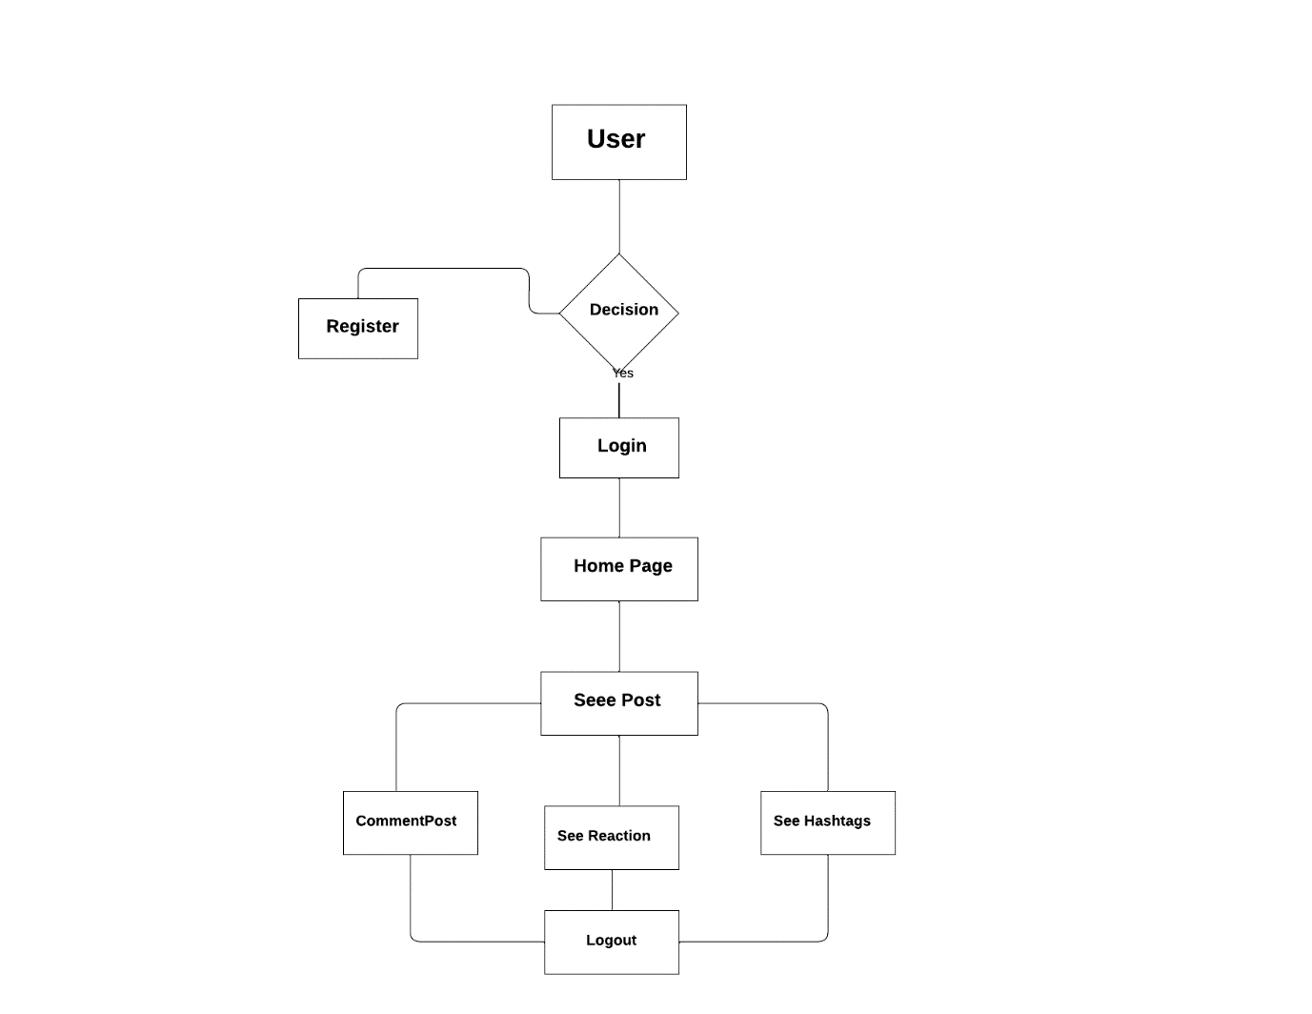

## 2.2 Web Application Screens

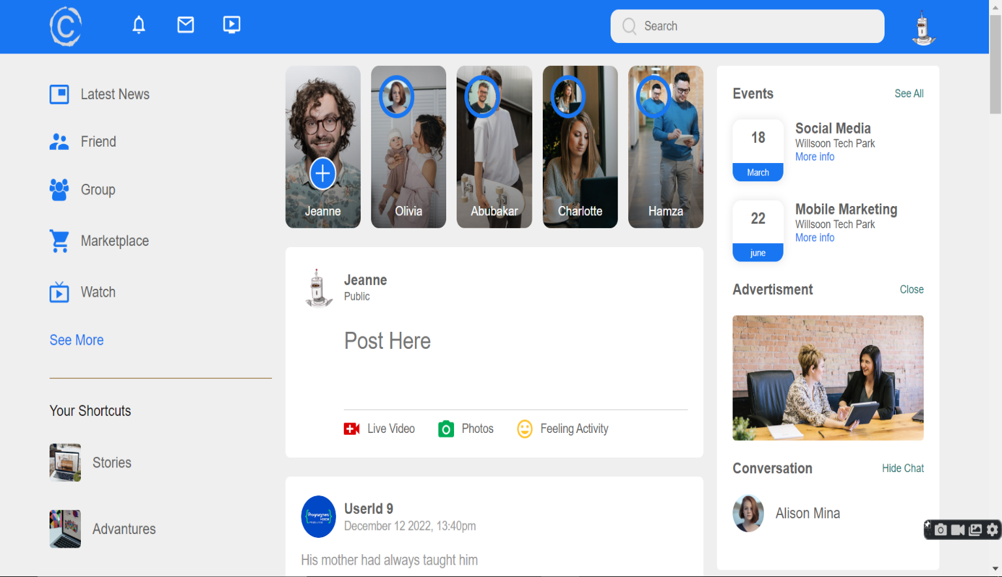

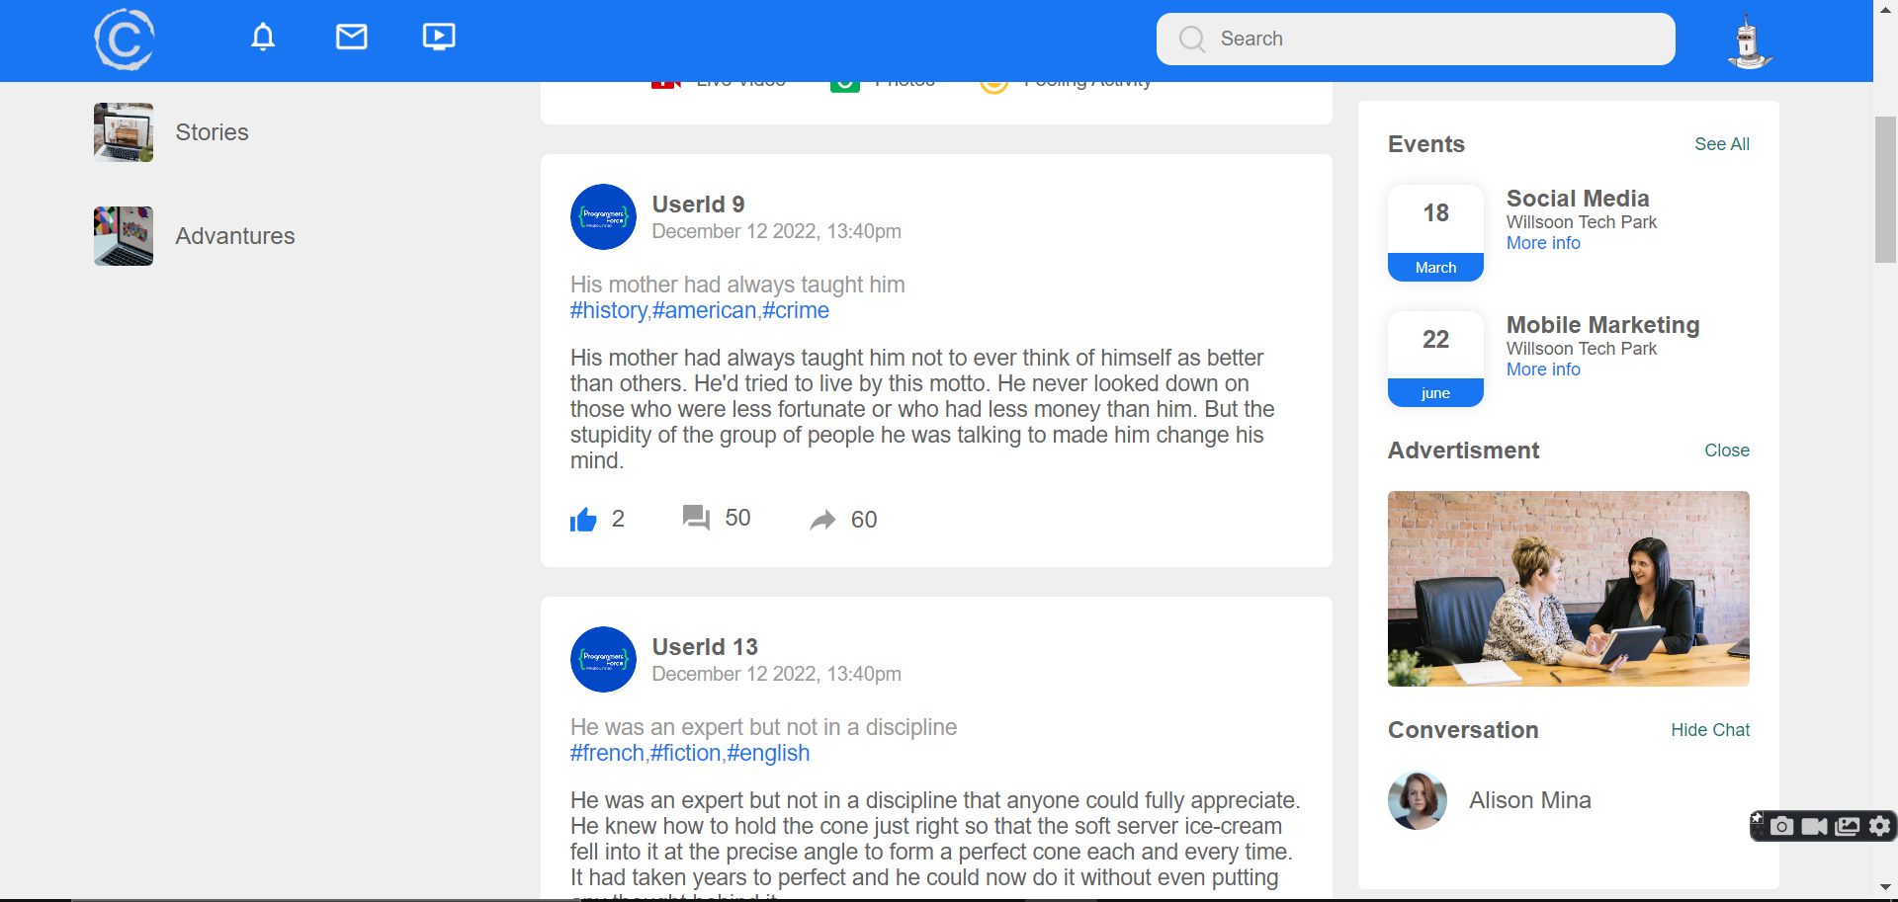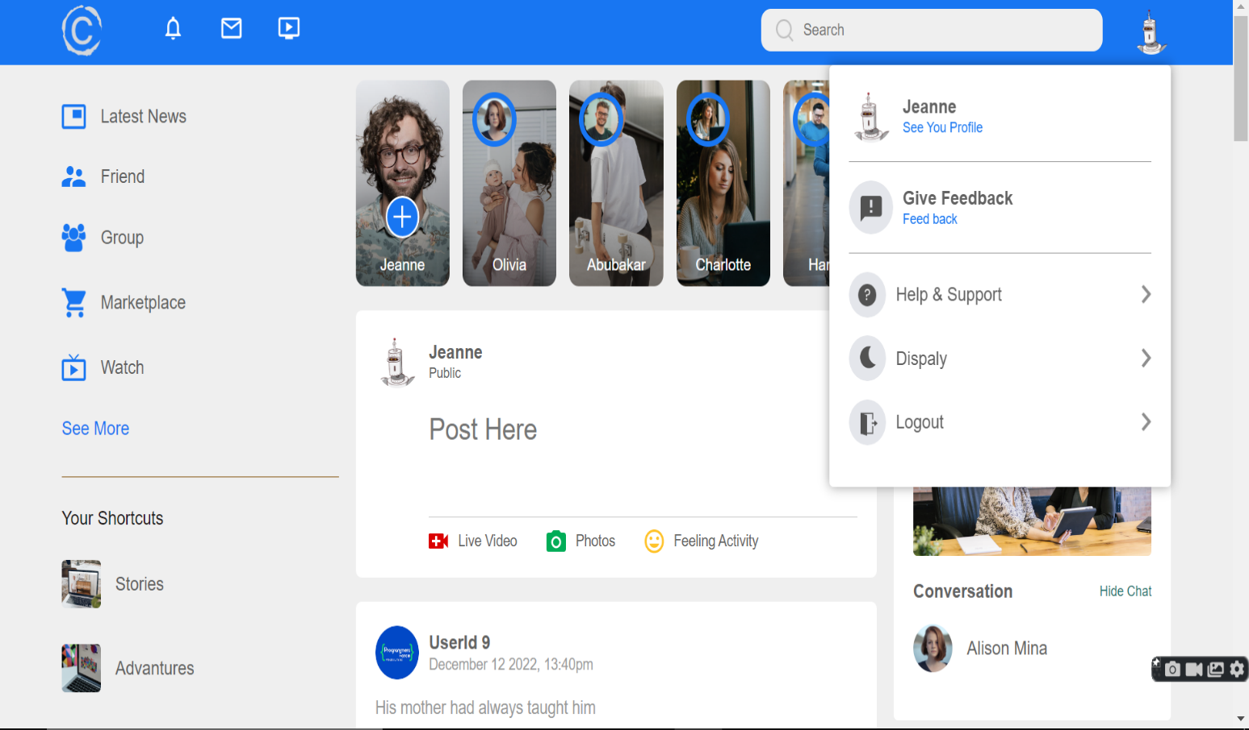

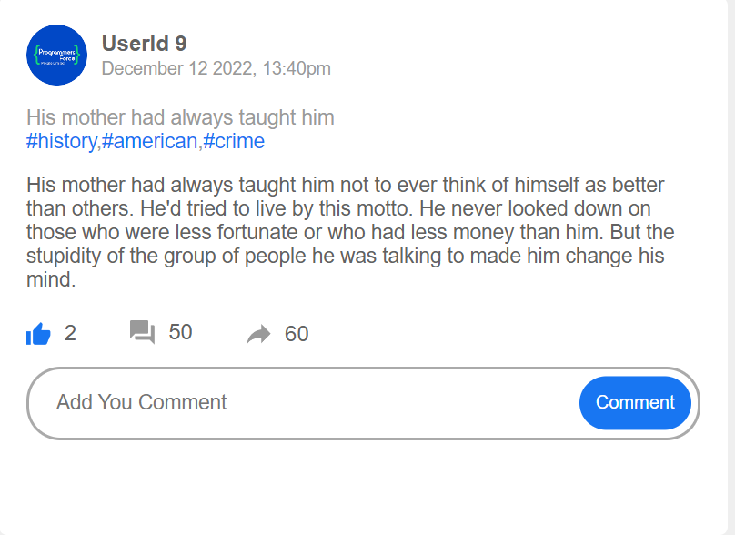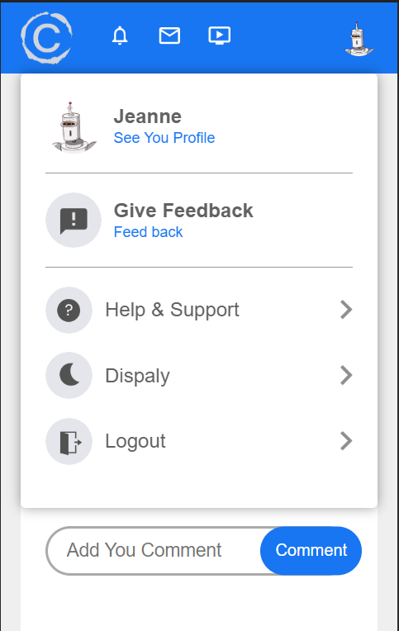**2.3 Mobile View**

